|  |  |  |  |  |  |
| --- | --- | --- | --- | --- | --- |
| Date | 6-Dec-22 | | | Tester Name | Mohammad Yusuf |
| Environment | Penfax - Test | | | Login used |  |
| Operating System | Select OS | Version: | Update: | | |
| Software Used | Select Software | Version: | Update: | | |
| Select Software | Version: | Update: | | |
| Release version |  | | | | |
| Title | M17 Contributions & DCT | | | | |
| Test Type | Regression | | | | |
| Test Scenario | M17.10 Creating an Enrolment File | | | | |
|  |  | | | | |
| Expected Results | New stakeholder should be created in Penfax. | | | | |
| Pass/Fail | Pass | | | JIRA# | N/A |

Describe your steps with screenshots:

1. Log into MEPP DCT and select the Employer from the dropdown. Click on Create New File.

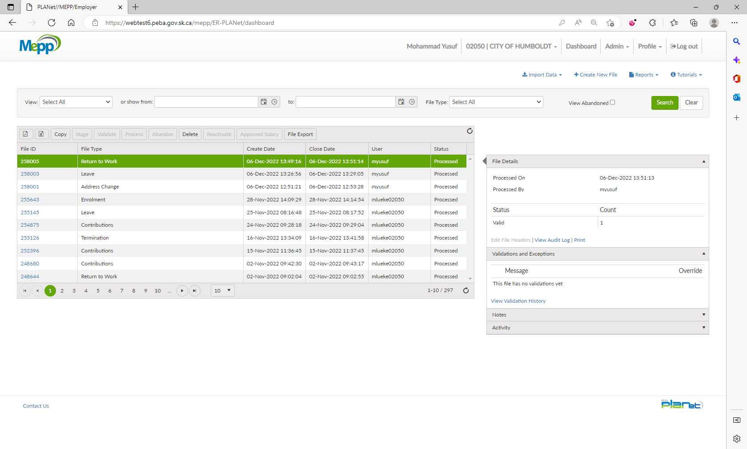

1. Select Enrolment from the dropdown and click Create.

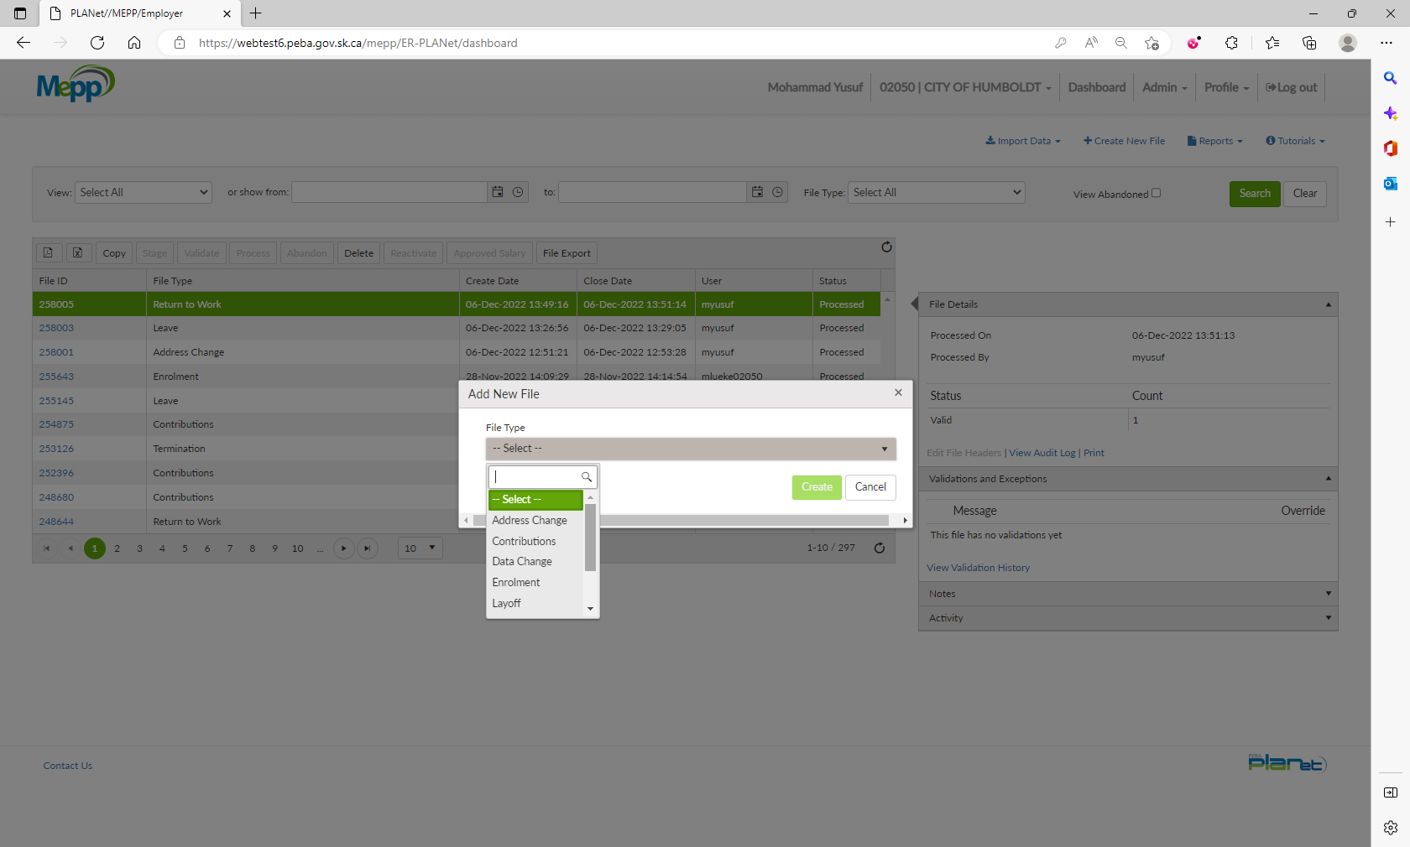

1. Click on File ID to add the transactions.

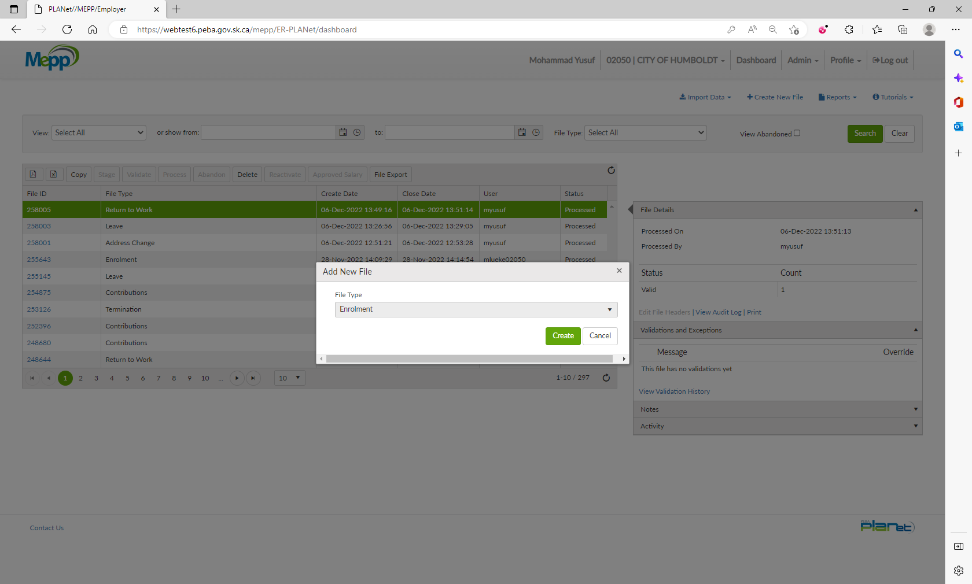

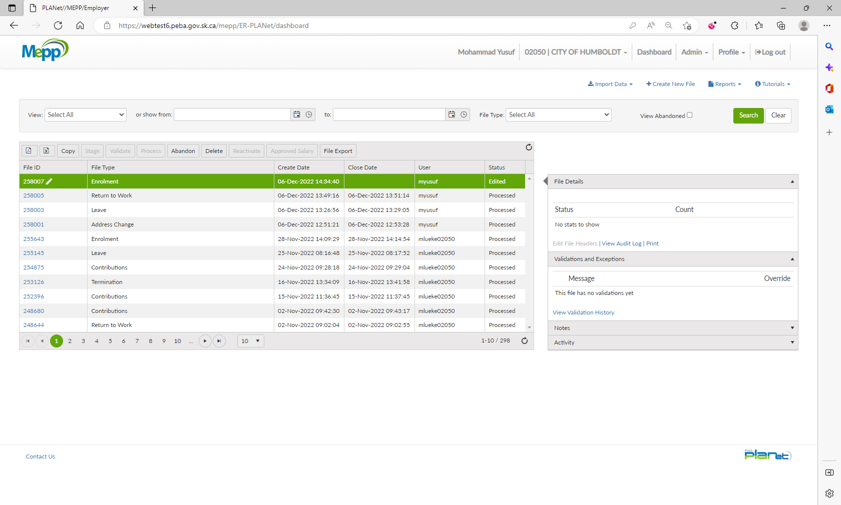

1. Input required details and click Save.

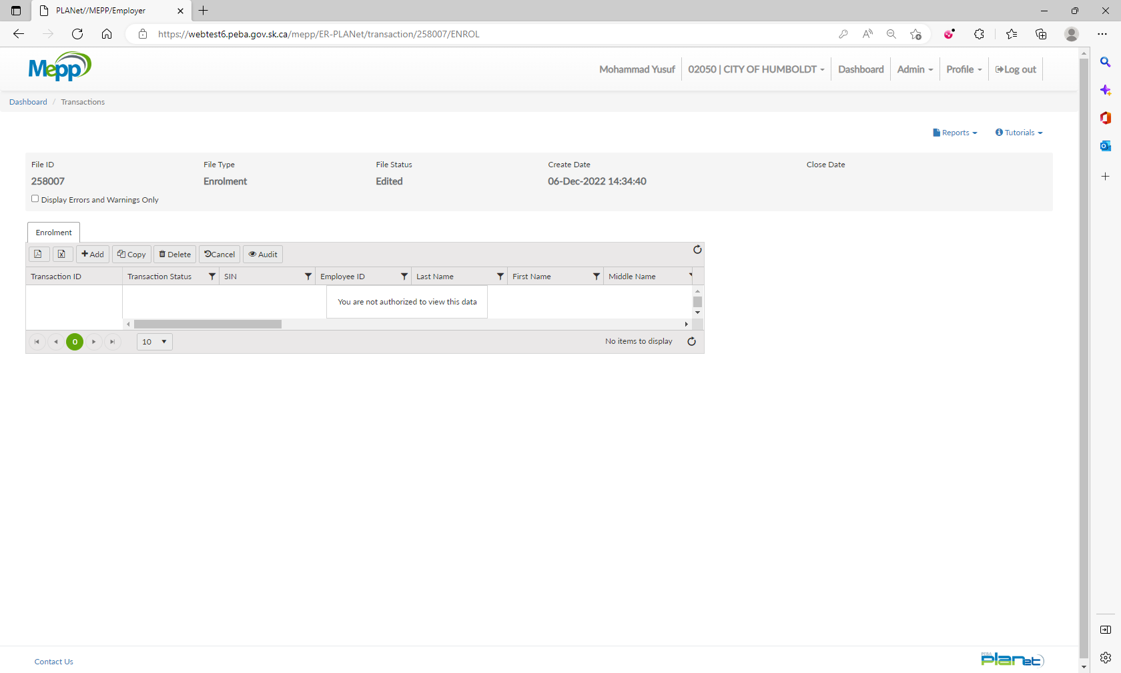

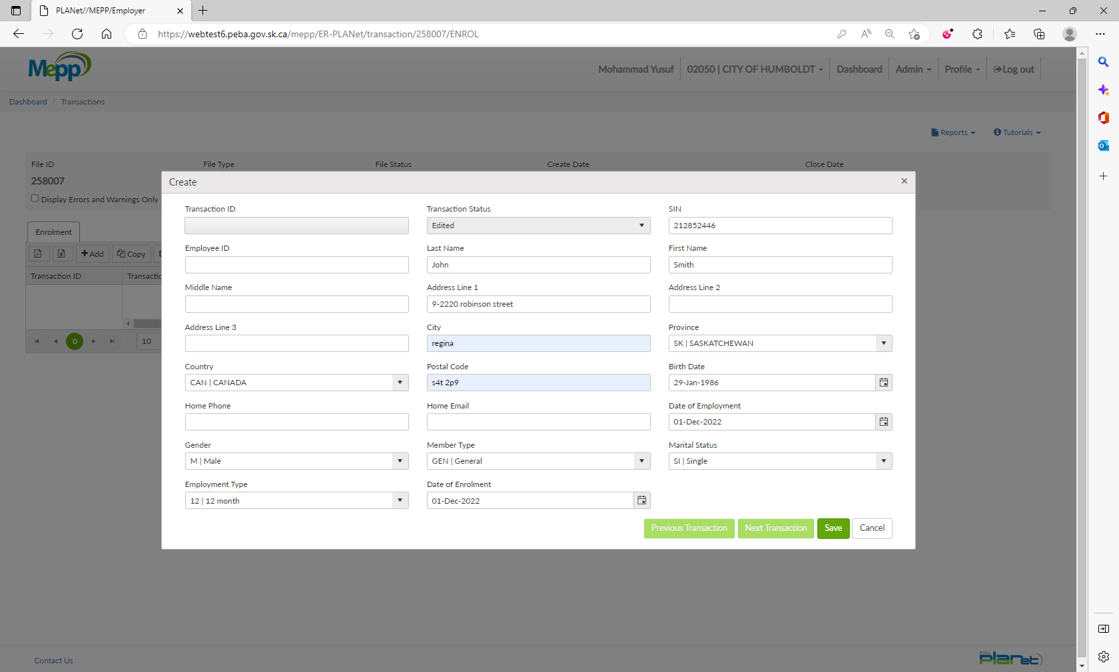

212 852 446

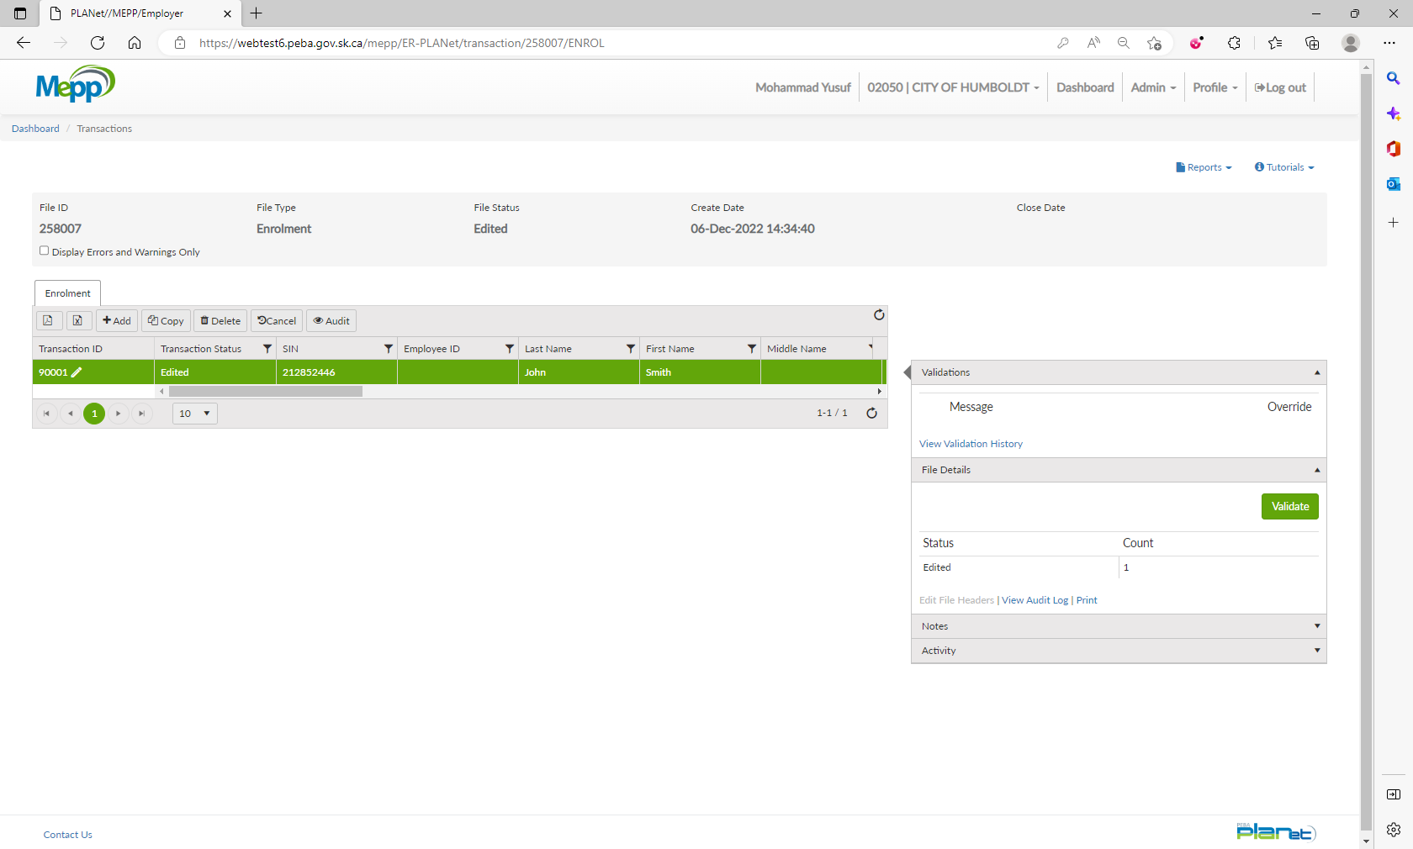

1. Under File Details, click on Validate and then Process.

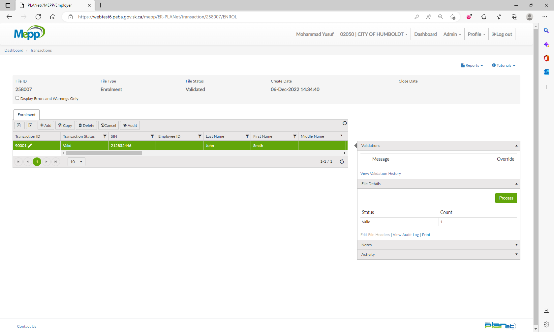

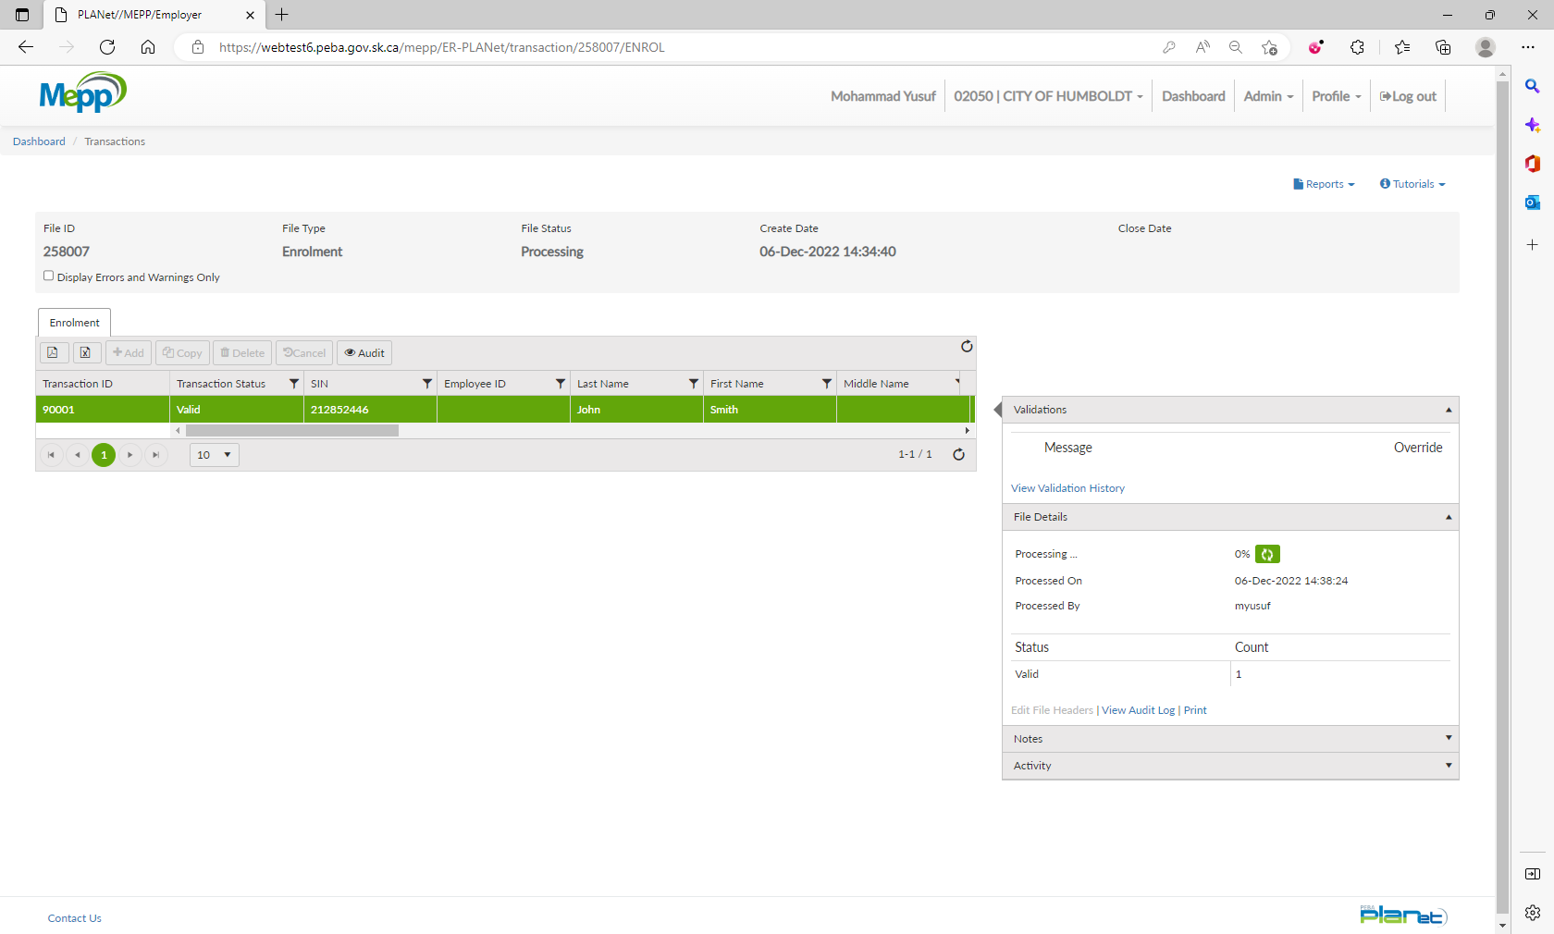

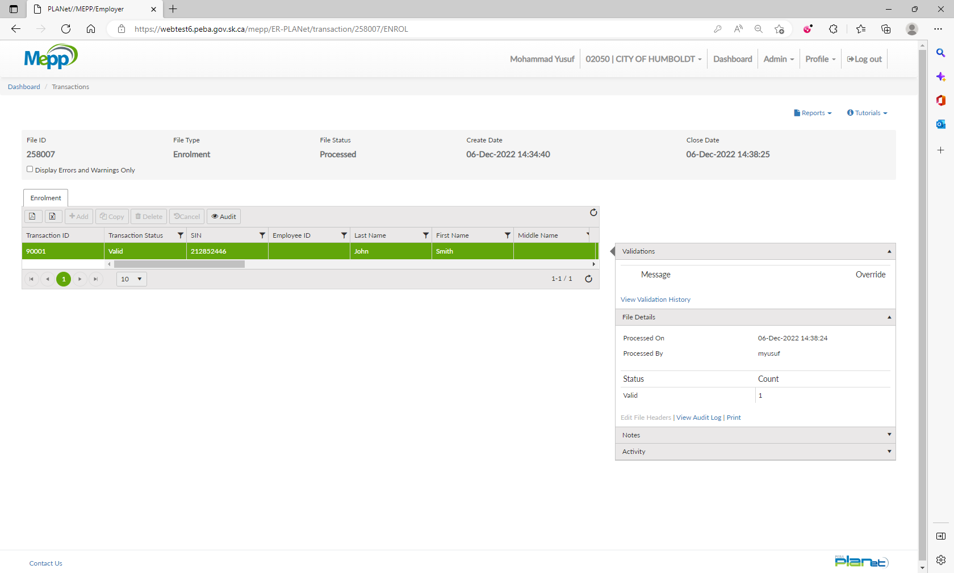

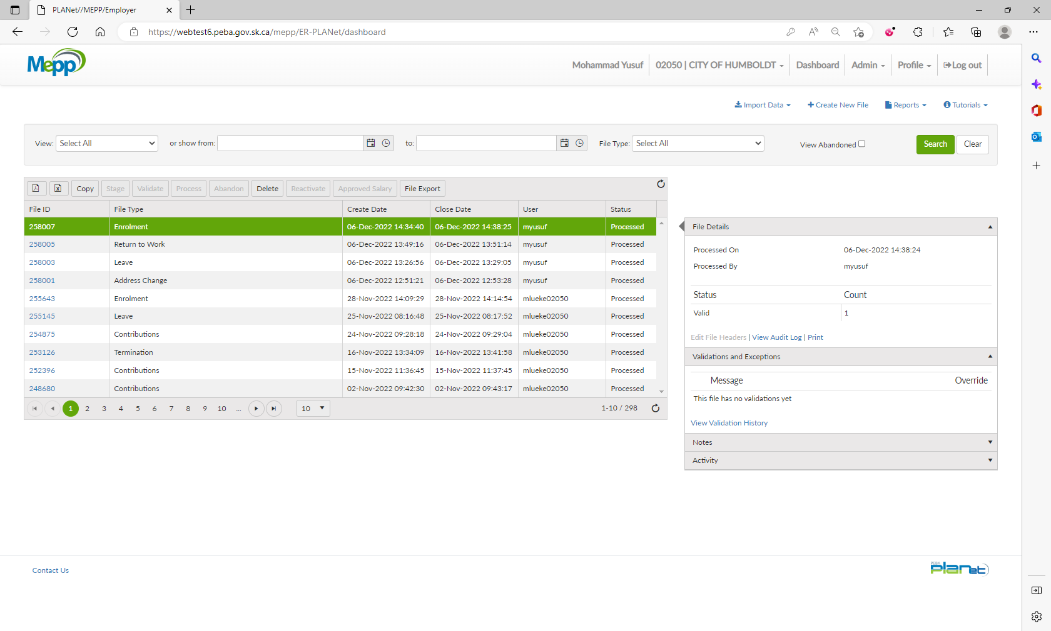

1. Go to Penfax -> Data Posting Batch -> Search by Batch Type and Employer.

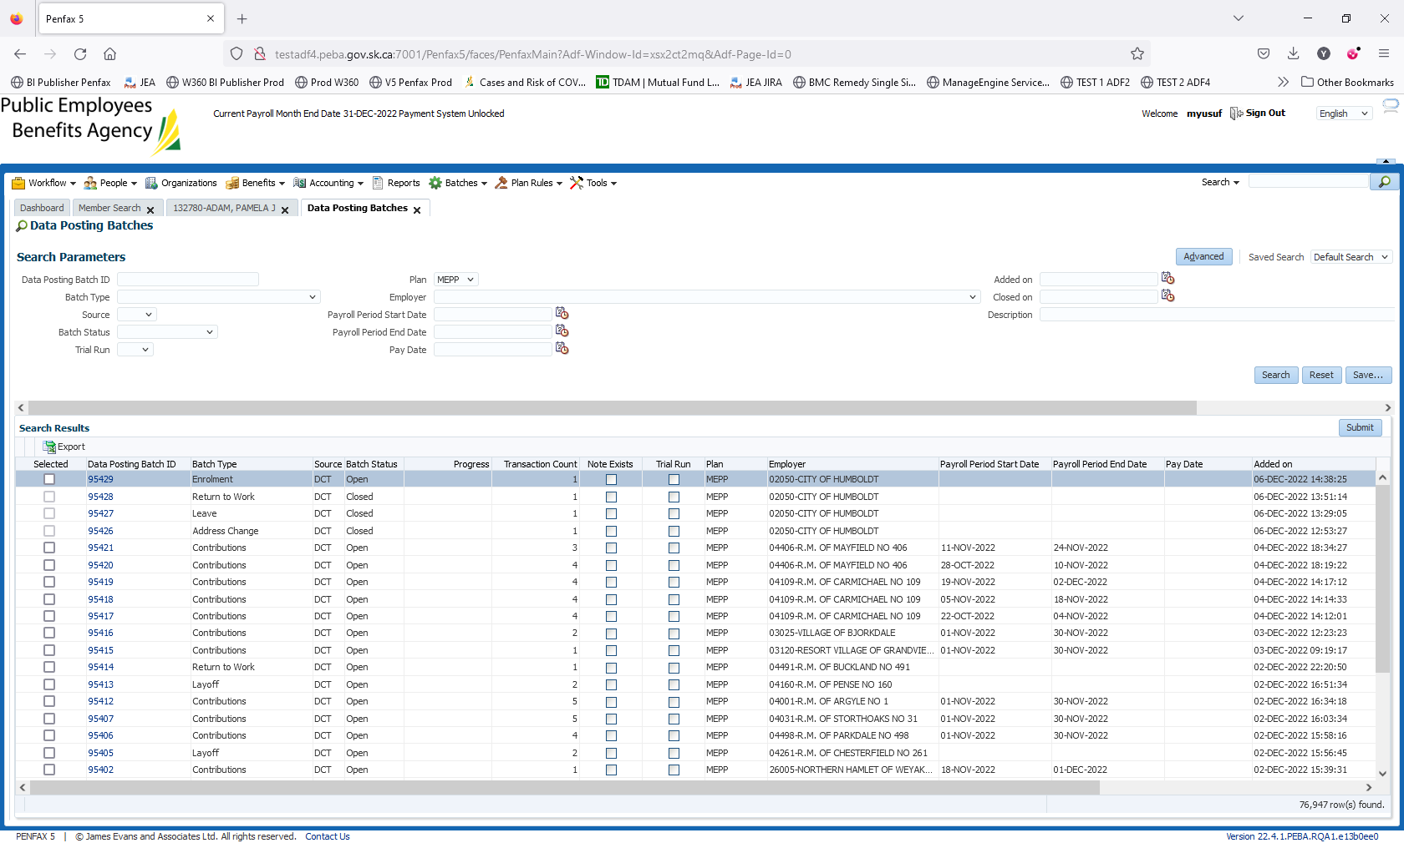

1. Open a batch you just processed through DCT. Go to Pending tab.

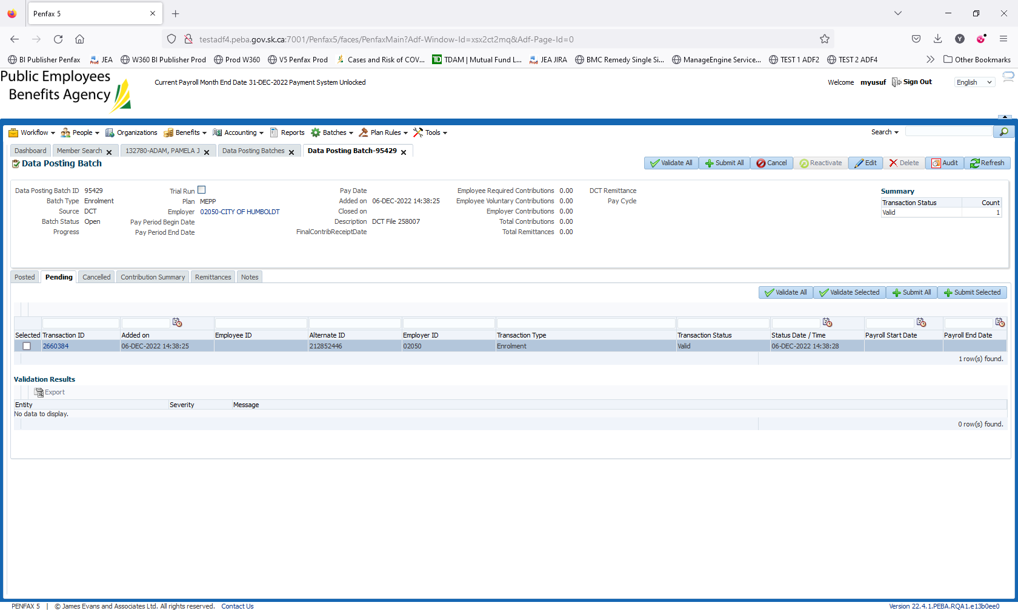

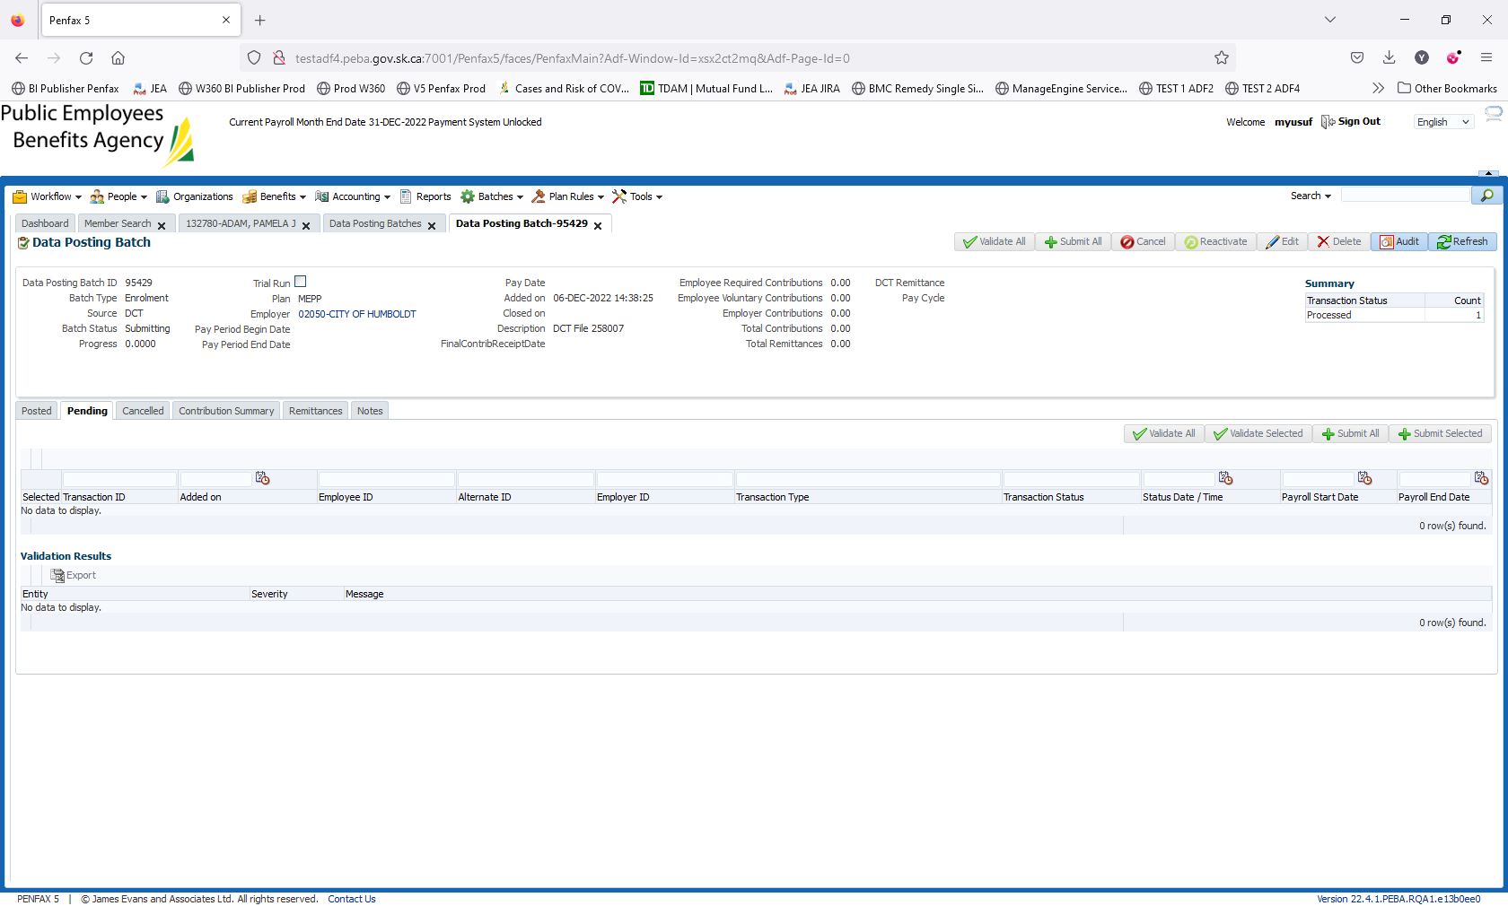

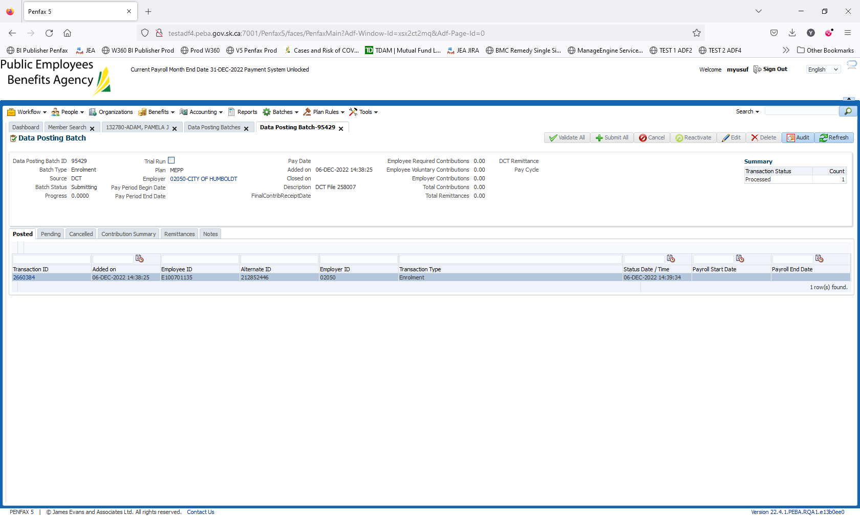

1. Click on Validate All and then Submit All.
2. Batch is submitted/processed. Transaction is moved to Posted tab. Batch Status is now Closed.

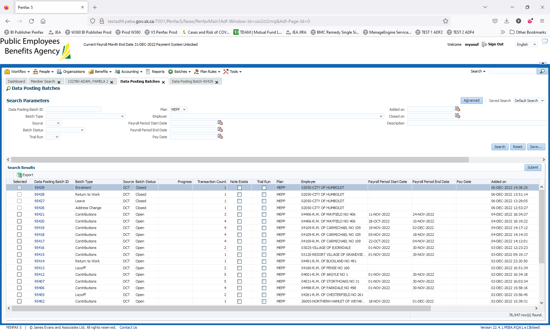

1. Click on Transaction ID.

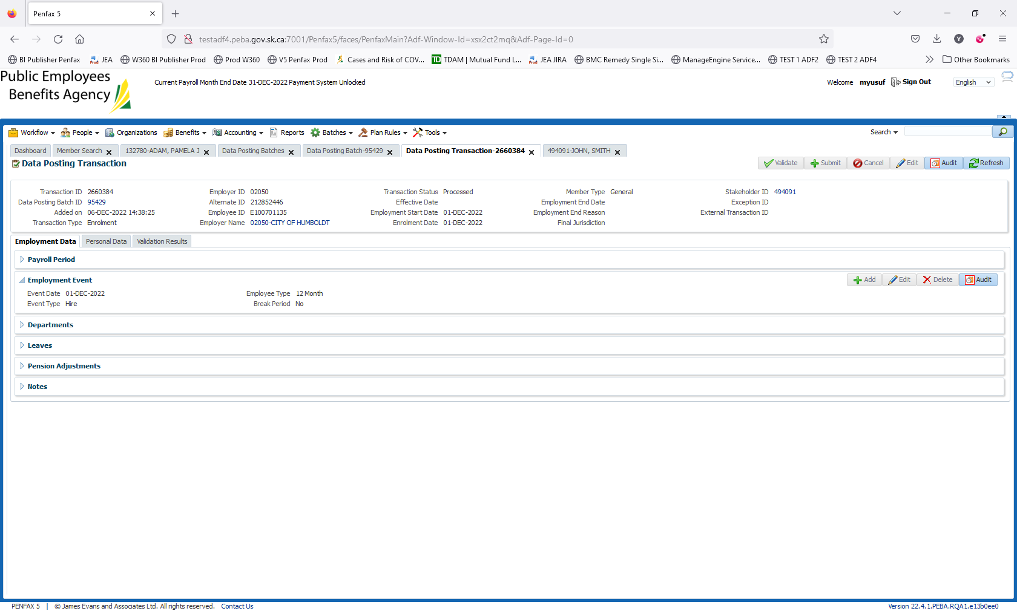

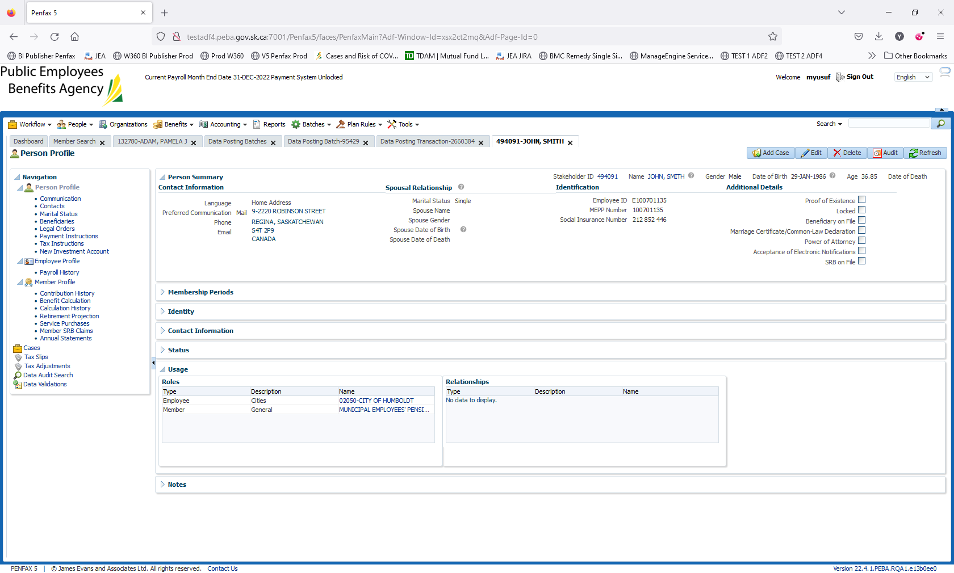

1. Click on Stakeholder ID to open it up.
2. New member account is created.